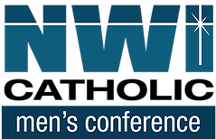

Northwest Indiana Catholic Men's Conference
FAITHFULNESS
St. John the Evangelist Catholic Church, St. John, IN
Saturday, November 6, 2021
8:00 a.m. – 3:00 p.m.

“AS FOR ME AND MY HOUSE, WE WILL SERVE THE LORD.”
Joshua 24:15
Come and listen to a dynamic team of speakers, encounter the living presence of Jesus Christ in word and sacrament, learn and grow as a disciple of the Lord, and meet and worship the Lord with other men of faith!

Featured speakers include:

- Paul J. Kim-
- Chris Stewart
- Matt Loboda
- TBA

This year's Conference includes:
Speakers, Music, Adoration
Confession, Holy Mass, and
online via YouTube live streaming

$30.00 Adult / $20.00 College or High School Student,
Includes a light continental breakfast and lunch
Or $10 per person for online live streaming

Register today online www.nwicatholicmen.com

